SE LAB-1
PES1UG24AM259
SHAMIKA MAHESH
5TH SEM (E-section)
Disaster Relief Supply & Volunteer Coordinator
Requirements Table | Problem Statement #64 | Sustainability & Green Tech
Target Stakeholders / Actors: Relief Volunteer, Disaster Manager

Functional & Non-Functional Requirements
` | Type | Description | Priority | Acceptance Criteria | Rationale
FR-001 | Functional | The system shall match incoming field shelter supply requisitions against available central warehouse supplies and allocate delivery priority. | High | Pass: Critical need (water/medical) given highest dispatch priority and routed to logistics manifest.  Fail: Low priority item dispatched ahead of water/medical needs. | Ensures life-critical supplies (water, medical kits) reach shelters before non-critical items, minimising harm during scarcity.
FR-002 | Functional | The system shall allow a Relief Volunteer to register and update a profile listing their skill set (e.g., medical, driving, logistics, first-aid). | High | Pass: Volunteer profile is saved with at least one valid skill tag and is searchable by the Disaster Manager.  Fail: Volunteer is dispatched without any recorded skill match. | Accurate skill records allow volunteers to be matched to tasks they are actually qualified to perform.
FR-003 | Functional | The system shall automatically recommend and dispatch a Relief Volunteer to a relief task based on required skill, proximity, and current availability. | High | Pass: Recommended volunteer list is ranked by skill match and distance, and top match receives a dispatch notification within 60 seconds.  Fail: A volunteer lacking the required skill is dispatched ahead of a qualified, available volunteer. | Automated matching reduces manual coordination effort and speeds up response time during time-critical emergencies.
FR-004 | Functional | The system shall track and display the real-time location and delivery status (e.g., En Route, Delivered, Delayed) of each relief vehicle. | Medium | Pass: Vehicle location updates on the dashboard at least every 2 minutes and status changes are timestamped.  Fail: A vehicle's status remains unchanged for more than 10 minutes despite an active trip. | Visibility into delivery progress lets the Disaster Manager re-route resources and informs shelters of expected arrival.
FR-005 | Functional | The system shall notify the Disaster Manager with a critical alert when any shelter's reported stock of water, blankets, or medical kits falls below a configurable threshold. | Medium | Pass: An alert is generated and shown on the dashboard within 5 minutes of stock falling below threshold.  Fail: Shelter runs out of a critical supply with no alert raised. | Early warning of critical shortages allows preventive resupply before a shelter runs out entirely.
NFR-001 | Performance & Security | The disaster mapping dashboard must operate with low network bandwidth consumption and support offline GIS data caching. | High | Pass: Benchmarking tests confirm target latency and security standards under simulated peak load.  Fail: Dashboard fails to load cached maps when connectivity drops. | Disaster zones frequently have degraded or intermittent connectivity; the system must remain usable under those conditions.
NFR-002 | Reliability & Availability | The system shall maintain 99.9% uptime during an active disaster event and must not lose any locally queued data (requisitions, status updates) when connectivity is restored after an outage. | High | Pass: Simulated 30-minute network outage test shows all locally queued updates sync successfully on reconnection with zero data loss.  Fail: Any queued requisition, dispatch, or status update is lost or duplicated after reconnection. | Coordination decisions depend on trustworthy, complete data; downtime or silent data loss during a disaster can directly cost lives.

Legend: Blue rows = Functional Requirements (FR-001 to FR-005) | Tan rows = Non-Functional Requirements (NFR-001, NFR-002)
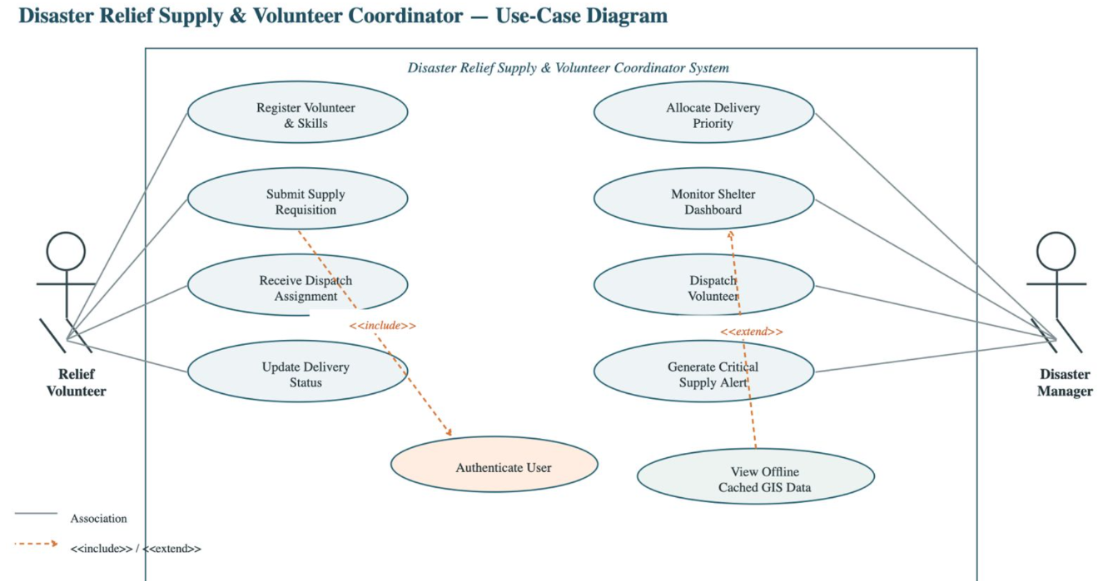
Use-Case Flow Specification
Disaster Relief Supply & Volunteer Coordinator | Problem Statement #64
Preconditions
- The Disaster Manager is authenticated and logged into the system (via the Authenticate User use case).
- A supply requisition has already been submitted by a Relief Volunteer or shelter and is present in the pending-requisitions queue.
- The central warehouse inventory data is current (last synced within the last 15 minutes).
Postconditions
- The requisition is assigned a priority level (Critical, High, Medium, or Low) and its status changes from Pending to Prioritised.
- A corresponding entry is added to the logistics dispatch manifest with the assigned priority.
- The requesting shelter and the logistics team receive a notification of the assigned priority and expected dispatch window.
Main Success Scenario
- The Disaster Manager opens the Pending Requisitions list on the dashboard.
- The system displays each requisition's requested item(s), quantity, requesting shelter, and time submitted.
- The Disaster Manager selects a requisition to review.
- The system checks the requisition's item(s) and quantities against real-time central warehouse stock levels (<<include>> Authenticate User has already run at login; this step re-uses that session).
- The system computes a suggested priority: Critical for water, medical kits, or any item flagged as life-sustaining when shelter stock is below the survival threshold; High/Medium/Low for all other items based on configured business rules.
- The system presents the suggested priority to the Disaster Manager along with the matched warehouse stock quantity.
- The Disaster Manager confirms (or manually overrides) the suggested priority.
- The system records the final priority, updates the requisition status to Prioritised, and adds the item to the logistics dispatch manifest.
- The system notifies the requesting shelter and the logistics/dispatch team of the confirmed priority and expected delivery window.
Alternate Flow — A1: Insufficient Warehouse Stock
Trigger: At step 4, the system finds that available warehouse stock is less than the quantity requested.
- The system flags the requisition as Partially Fulfillable and shows the Disaster Manager the shortfall quantity.
- The Disaster Manager chooses to either (a) dispatch the available partial quantity immediately at Critical priority, or (b) place the remaining shortfall on a back-order queue pending the next warehouse resupply.
- The system records the chosen option, updates the requisition status accordingly (Partially Dispatched or Back-Ordered), and adds any dispatched portion to the logistics manifest.
- The system generates a critical supply alert to the warehouse team for the shortfall item, so restocking can be prioritised.

